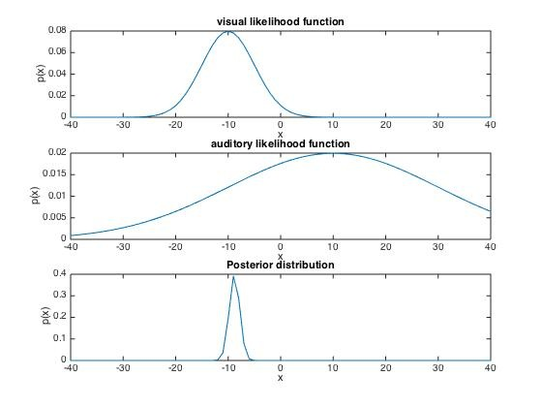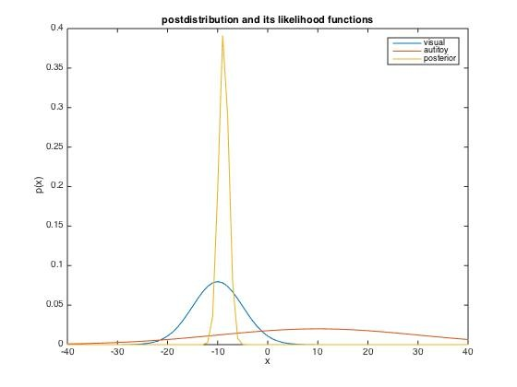2b

Posterior mean is the average of the prior mean weighted by precision of each prior Gaussian distributions. The larger the variance is , the smaller the weight is. Therefore, the posterior mean lean to the mean of visual data, since visual data has smaller variance.

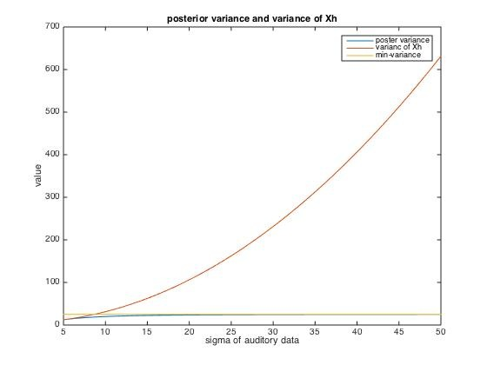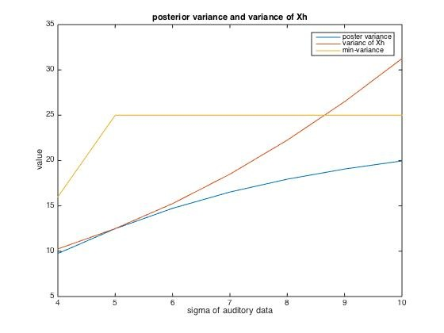

2d

Visual signal is the horizontal part of the min-variance, for auditory variance is a increasing function in the function min(auditory variance,

visual variance). Therefore, when sigma of auditory data reached 8.66, variance of Xh become worse than just using the visual signal alone.

Posterior Variance is always smaller than minimum variance of the two sensory sources.